Manila Water Company
technical specification – WORK FLOW

DID_R2R_212

Investment Ticket

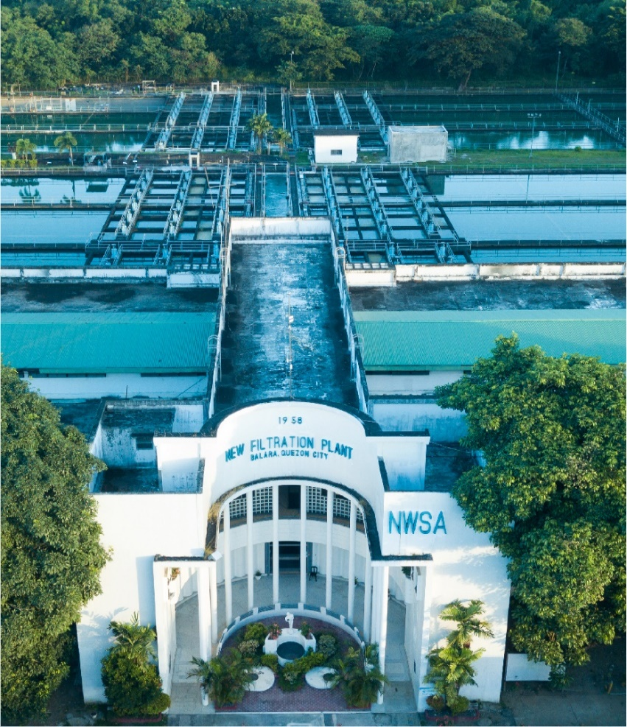



Contents
1 Document Organization 5
1.1 Document Log 5
1.2 Integration, Document Reference 5
2 Program Attributes 6
2.1 Selection Screen 6
2.2 Validation of Selection Criteria 7
2.3 CDS Views/AMDP/Table Function 7
2.3.1 Selection Condition 7
2.3.2 Join Condition 7
2.3.3 Fields 7
2.3.4 Additional Details 7
2.3.5 GIT Repository Details 7
2.4 Authorization Requirements 8
2.4.1 Definition 8
2.4.2 Defined Fields 8
2.4.3 Procedure 8
2.4.4 DCL Details 8
2.4.5 BTP Details 8
2.5 Technical Flow Diagram 8
2.6 UI Details 8
2.6.1 UI Mock Screens 8
2.6.2 Navigations 9
2.6.3 Actions 9
2.6.4 Validations 9
2.6.5 Other Details 10
2.7 Processing Logic 10
2.8 Reusable Code 10
2.9 Messages 10
2.10 Subroutines 11
3 Report Output 11
3.1 Output Method 11
3.2 Main Heading 11
3.3 Sub Heading 11
3.4 Layout / UI Design 11
3.5 Totaling 12
3.6 Sorting 12
3.7 Page Break 12
3.8 Error Handling 12
3.9 Report Header & Footer 12
4 Assumptions in Technical Design 12
5 Open Issues in Technical Design 12
6 Unit Test Results 12
7 Related Documentation 13

Document Organization
This section provides details about this document, previous version(s) of this document and the document(s) referred.

Document Log
Following table mentions the version changes and the processer(s):
Version | Status | Date | Version Created by (Name/E-Mail/Company) | Role | Comments
1.0 | Draft | April 13, 2025 | Vipul Tamboli | Author
 | Choose an item. | Click here to enter a date. |  | Choose an item.

Integration, Document Reference

S. No. | Referred Document Name | Referred Document Version | Referred Document URL (Optional)
N/A | N/A | N/A | N/A

Program Attributes
Program title | Investment Ticket
Program Name | ZAB_R2R_INVTICKET_CREATE  ZAB_R2R_INVTICKET_CHANGE  ZAB_R2R_INVEST_TKT_APPROVE
Program Type | Executable
Package | ZS4_MWC_R2R_TRM
Authorization Group | N/A

Transaction Code | ZTR_R2R_INV_CREATE  ZTR_R2R_INV_CHANGE  ZTR_R2R_INV_APPROVE
Include Programs | INCLUDE ZIN_R2R_INVTICKET_CREATE_TOP.  INCLUDE ZIN_R2R_INVTICKET_CREATE_F01.  INCLUDE ZIN_R2R_INVS_CHANGE_TOP.  INCLUDE ZIN_R2R_INVS_CHANGE_F01.  INCLUDE ZIN_R2R_INVS_CHANGE_E01.  INCLUDE ZIN_R2R_INVST_APP_TOP.  INCLUDE ZIN_R2R_INVST_APP_E01.  INCLUDE ZIN_R2R_INVST_APP_F01.
Function Modules | REUSE_ALV_GRID_DISPLAY  FP_FUNCTION_MODULE_NAME  BAPI_USER_GET_DETAIL  F4IF_INT_TABLE_VALUE_REQUEST

SAP Tables Read | T012K  VTBFHA  VTBFHAPO  PA0001  T012  BNKA
Custom Tables | ZDT_R2R_INTK_HDR  ZDT_R2R_INTK_SRC  ZDT_R2R_INTK_LQY
Custom Indexes | N/A
CDS Views | IEMPLOYEEDETAILS
OData Service | N/A
Business Object | N/A
Fiori App Name
Group Name | N/A
Catalog Name | N/A

Selection Screen
- ZTR_R2R_INV_CREATE
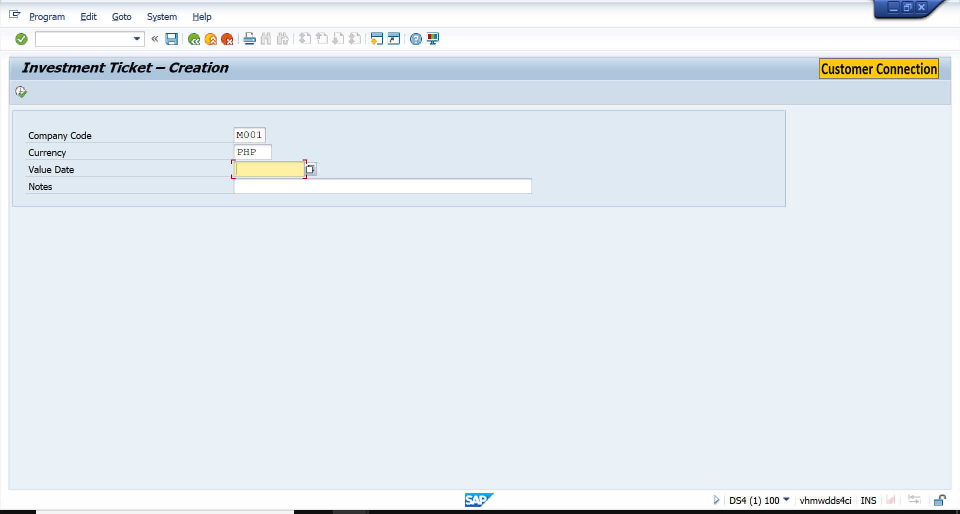

- ZTR_R2R_INV_CHANGE
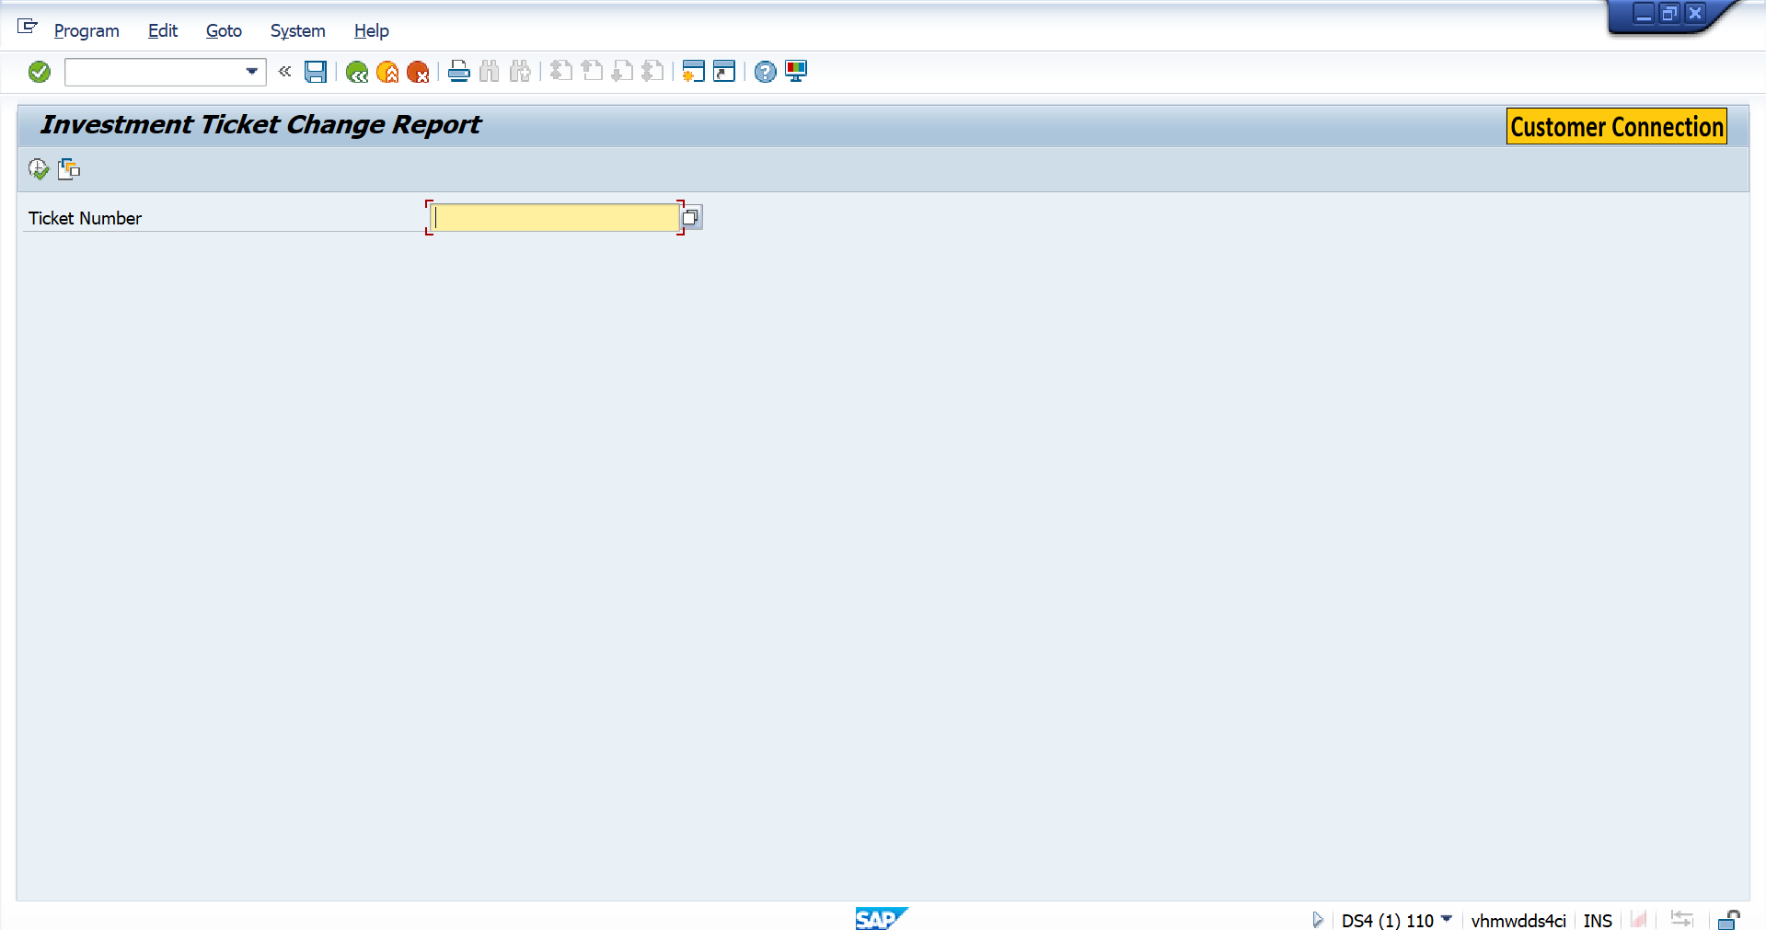
- ZTR_R2R_INV_APPROVE
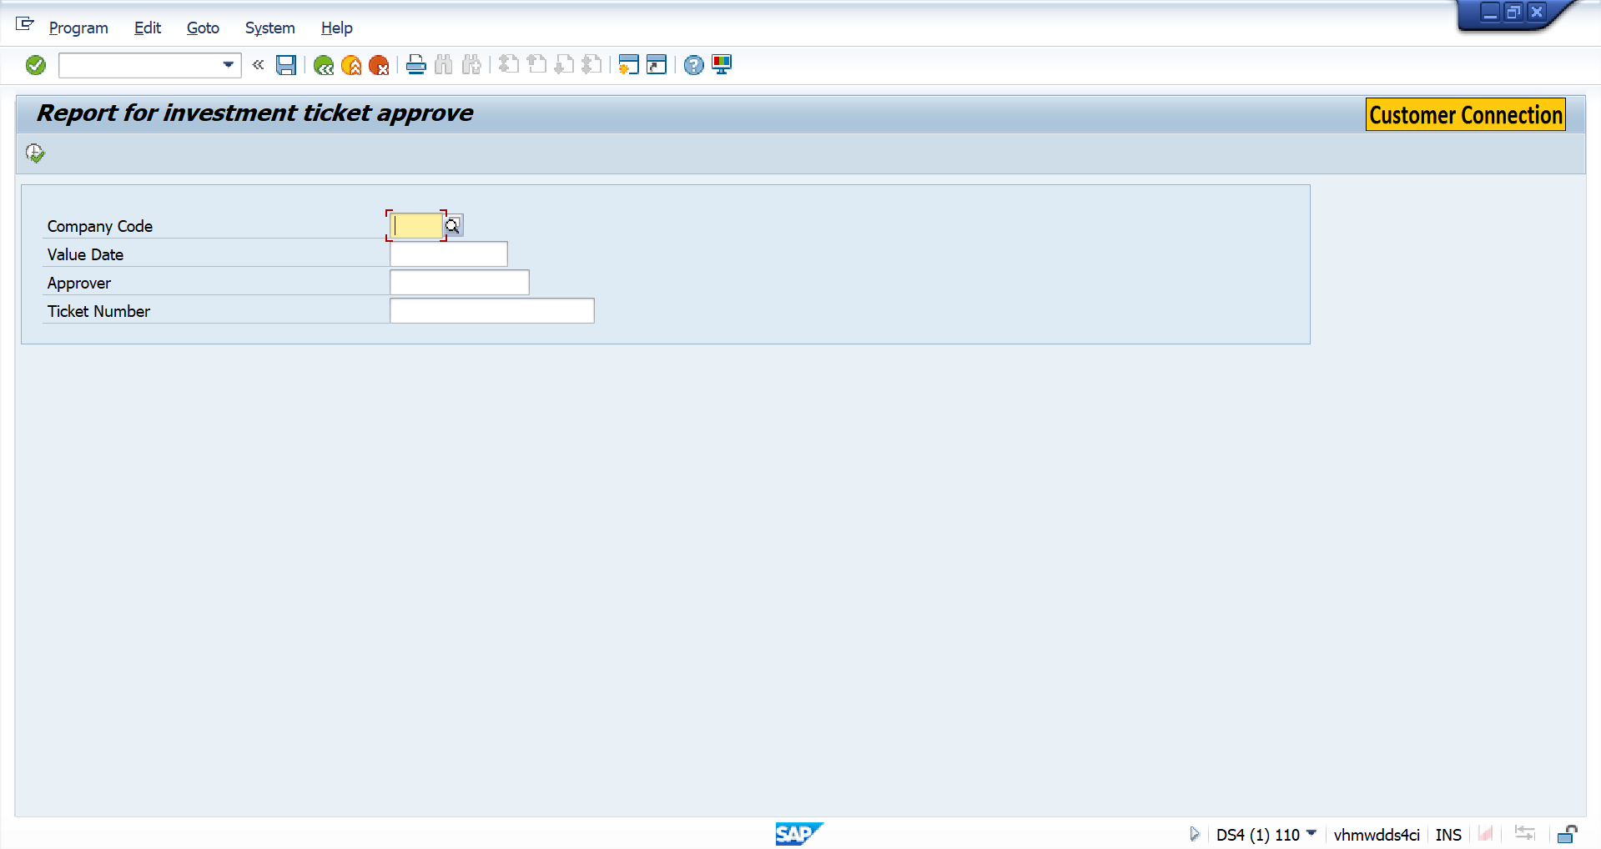

Validation of Selection Criteria
- ZTR_R2R_INV_CREATE
- Company Code
- Currency

- ZTR_R2R_INV_CHANGE
- Ticket Number

- ZTR_R2R_INV_APPROVE
- Company code
- Value Date
- Approver
- Ticket Number

CDS Views/AMDP/Table Function
- IEMPLOYEEDETAILS

Selection Condition
N/A

Join Condition
N/A

Fields

N/A

Additional Details
N/A

GIT Repository Details

N/A
Development Details
GIT Location | N/A
GIT URL | N/A

Authorization Requirements
N/A

Definition
N/A

Defined Fields
N/A

DCL Details
N/A

BTP Details

xs-security Configuration | N/A
IDP Setup | N/A
BTP Role Collections | N/A

Technical Flow Diagram
- ZTR_R2R_INV_CREATE
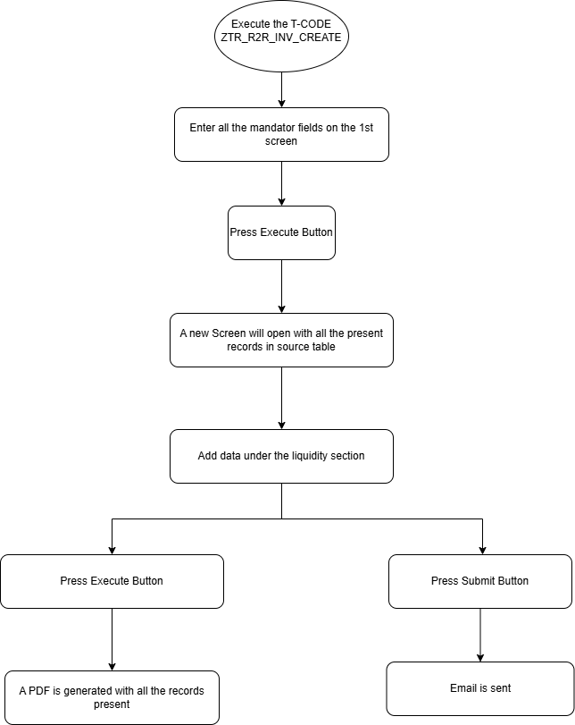
- ZTR_R2R_INV_CHANGE
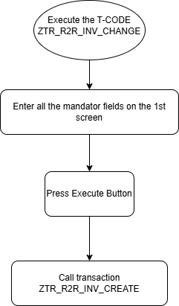
- ZTR_R2R_INV_APPROVE
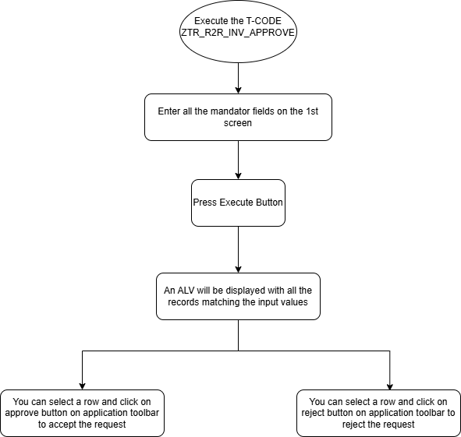

UI Details
N/A

UI Mock Screens

Application Name
Site | N/A
URL | N/A
Mockup | N/A

Navigations

Source View | Target View / URL | Pattern
N/A | N/A | N/A

Actions

Application | Screen(s) | Action | Type | Action Description
N/A | N/A | N/A | N/A | N/A

Validations
Application | Screen(s) | Field/Button | Validation Logic – Method, function details
N/A | N/A | N/A | N/A

Other Details
N/A

Processing Logic
- ZTR_R2R_INV_CREATE
1.1. Enter the input values on the initial screen
• Fields include: Company Code, Currency, Value Date, and Notes.
• These inputs define the overall context for the liquidity plan.
2.2. Press the "Execute" button
• The system navigates to the detailed planning screen.
2.3. Enter values in the Source of Funds table
• Fill in entries like Fresh Fund and Requirements.
2.4. Enter records in the Liquidity Decomposition table

2.5. Enter the Approver
• Select or enter the name of the Approver on this same screen.
• The Approver will receive the submission and is responsible for reviewing the liquidity plan.
2.6. Press the "Execute" button
• The system generates a PDF form containing all the entered data.
2.7. Alternatively, press the "Submit" button
• The system sends an email with the generated PDF to the specified Approver.
- ZTR_R2R_INV_CHANGE
2.1. Enter the Ticket Number on the selection screen
• This is the unique identifier of an already created liquidity plan.
2.2. Press the "Execute" button
• The system fetches the existing data from the custom table based on the entered Ticket Number.
• Navigates to the transaction ZTR_R2R_INV_CHANGE in Edit Mode.
2.3. Review and update the fields
• All previously entered fields are pre-filled.
• You can modify any editable fields based on business needs.
• Some fields may be read-only, depending on the status or validation rules.
2.4. Save or Submit
• Press "Execute" to regenerate the PDF with the updated information.
• Press "Submit" to send the updated plan via email to the Approver.
- ZTR_R2R_INV_APPROVE
3.1. Enter the selection criteria on the input screen
• Mandatory/optional fields include:
- Company Code
- Approver
- Value Date
- Ticket Number
3.2. Press the "Execute" button
• The system filters and displays liquidity plans based on the entered criteria.
• Records are shown in a list format with relevant status and details.
3.3. Select a record from the list
• You must be authorized as the listed approver to take action.
• If authorized, the Approve and Reject buttons will work otherwise it will give an error.

3.4. Approve or Reject
• Click "Approve" to mark the record as approved.
• Click "Reject" to mark the record as rejected.
3.5. Double-click a record to view details
• Opens the PDF form associated with the selected liquidity plan.

Reusable Code
N/A

Messages

Subroutines
Name | Description
N/A
N/A
N/A

Report Output

Output Method

Main Heading

Sub Heading
N/A

Layout / UI Design
N/A

Totaling
N/A

Sorting
N/A

Page Break
N/A

Error Handling
N/A

Report Header & Footer
N/A

Assumptions in Technical Design

Unit Test Results

Scenario # | Input Selection Criteria | Expected Result | Actual Test Pass/Fail
1 | Execute Fiori App - MWC Create Investment Ticket and provide input parameters. | Investment Ticket is generated and submitted for approval. | Pass
2 | Approver receives the SAP Inbox notification and approves the Investment Ticket. | Mail notification to Trader.  Workflow is completed. | Pass
3 | Execute Fiori App - MWC Review Investment Ticket and provide input parameters. | Investment Ticket is edited and submitted for approval again. | Pass
4 | Approver receives the SAP Inbox notification and rejects the Investment Ticket. | Mail SAP Inbox notification to the creator.  Workflow item sent back to the creator. | Pass

Related Documentation

Template Version
Version | Status | Date | Version Created by (Name/E-Mail/Company) | Role | Comments
1.0 | Final | February 11, 2019 | Sweety | Author
1. | Final | March 15, 2022 | Sweety | Author | Updated to accommodate details of Fiori/UI5 Application related artifacts using ABAP programming model for SAP Fiori Elements

